Agile Bronze learning – Experience Paper

**Concepts:**

1. Agile principles and methodologies
2. Agile project planning
3. Agile Software Development
4. SCRUM
5. Agile Business Analysis
6. **Agile principles and methodologies:**

* Extreme Programming

It is a framework that enables teams to create high-quality software that helps improve their quality of life. It enables software development alongside appropriate engineering practices. It is applicable while handling changing software requirements risks caused due to new software, working with a small, extended development team, and technology that allows automated unit and functional tests.

* Kanban

It is a method that’s used to design, manage, and improve the flow of systems. Kanban enables organizations to visualize their flow of work and limit the amount of work in progress. It is used in situations where work arrives unpredictably, and where it needs to be deployed immediately without waiting for other work items.

* Lean

It is a set of tools and principles that focuses on identifying and removing waste to speed up process development. Value is maximized, and waste is minimized. It is used in just about every industry that produces waste in some form.

* Scrum

It is a framework used by teams to establish a hypothesis, test it, reflect on the experience, and make adjustments. It enables teams to incorporate practices from other frameworks depending on the requirements. It is used by cross-functional teams that are working on product development, and the work is split into more than one 2-4 week iterations.

* Crystal

It focuses on people and their interactions, rather than on tools and processes. Aimed to streamline processes and improve optimization, Crystal works on the principle that projects are unique and dynamic. It is used when the focus is on strengthening team communication, continuous integration, active user involvement, and configurable processes.

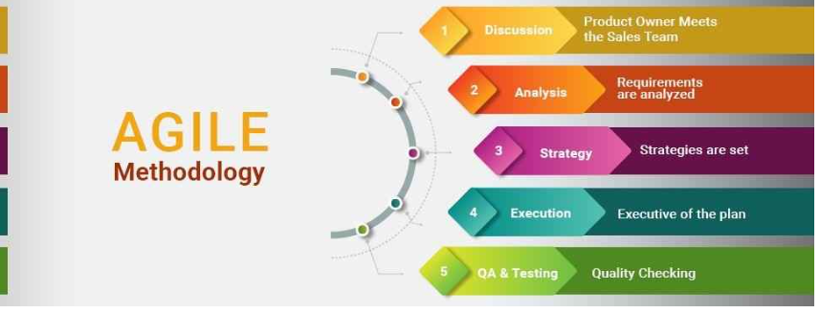

* Early and continuous delivery of valuable software.
* Embrace change.
* Frequent delivery.
* Cooperation.
* Autonomy and motivation.
* Better communication.
* Working software.
* Stable work environments.

1. **Agile project planning**

Planning helps streamline project management since it’s easier to iterate faster and launch increments when everything is planned out ahead. The agile planning serves as a comprehensive framework for agile planning, from the start to the finish, and as a result, should serve as a handy guide, both for implementing and perfecting planning on an agile team.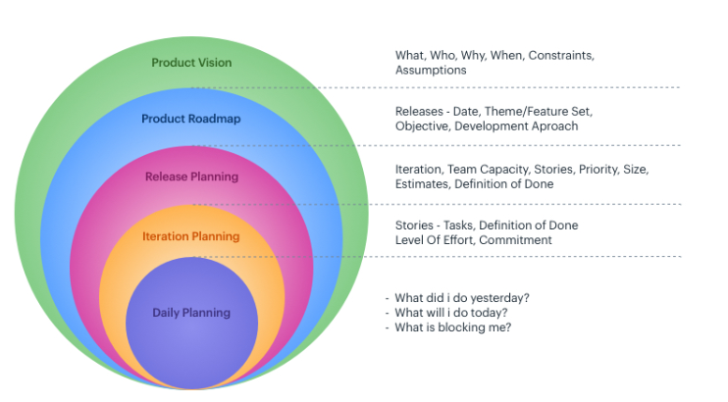

1. **Agile Software Development:**

Agile software development refers to a collection of methodologies and frameworks that promote adaptive planning, evolutionary development, and continuous delivery. Instead of focusing on a final output — the finished product — agile teams prioritize working in short increments with frequent release cycles to deliver value faster.

Software development is an adventure. And like most adventures, it is unpredictable. That is why agile philosophy centers around rapid iteration — solutions evolve organically through cross-functional collaboration between self-organizing teams. Customer satisfaction is on the horizon, with their feedback incorporated throughout the development process.

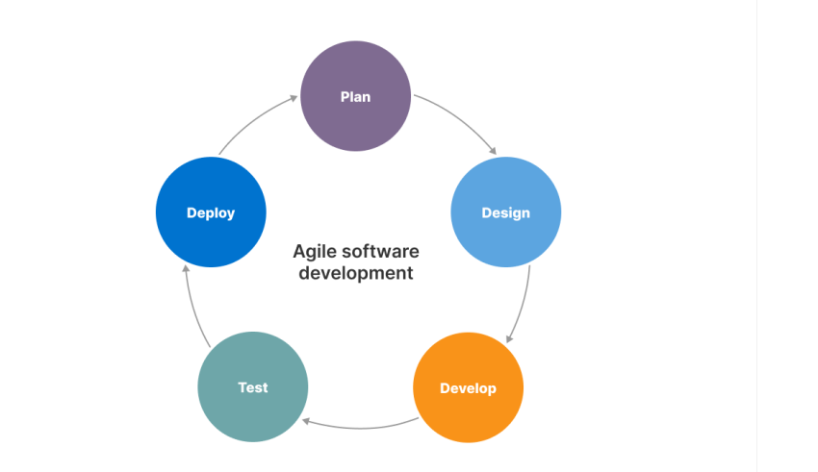

1. **SCRUM:**

The three pillars of scrum are Transparency, Inspection, and Adaption.

Transparency - Scrum is more about making things visible to all people involved. It starts with the vision and ends with the deliverables. Each individual is responsible for making things visible loud and clear with no gap in the communication of the information or the content.

Inspection - Everyone involved in the scrum process needs to inspect the scrum artifacts, namely, the product backlog, sprint backlog, team board, etc. to check if they are aligned with the Sprint goal, and to check whether the Sprint goal is itself in line with the vision.

Adaption - With inspection, if the team finds any deviation in the plan, or if during the inspection they feel they need to change the way they work, they can come up with new ways to adapt. While this is usually done in the retrospective meeting, the best practice is to inspect and adapt as and when required.

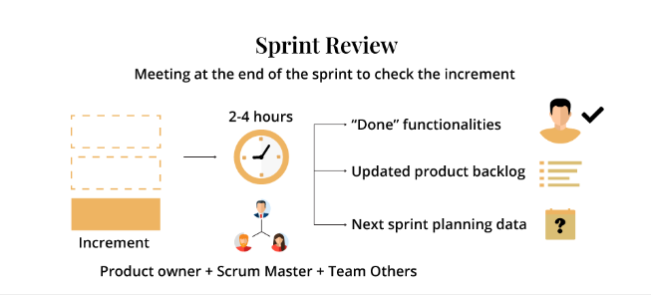

1. **Agile Business Analysis:**

Agile business analysis is the practice of business analysis in an Agile environment with an Agile mindset. The focus is maximizing business value of any solution and applying the Agile principles of inspecting and adapting.

An Agile BA mindset guides the business analyst and their way of working. It aligns with the Agile principles, especially with the key elements of inspecting and adapting. It means you focus on delivering value rapidly and consistently, collaborate with others to get the work done, iterate to continually learn, simplify to avoid waste, and consider the context in which you are working. In short, it means continually inspecting, reflecting, and adapting to both the current realities and business/team feedback in order to ensure the highest quality product has been created.